CLTA Form 100.2.7-06: Restrictions, Encroachments, Minerals – Lander Under Development – Loan Policy
ENDORSEMENT
Issued by

FIRST NATIONAL TITLE INSURANCE COMPANY

Attached to Policy No. ___________________________

1. The insurance provided by this endorsement is subject to the exclusions in Section 5 of this endorsement; and the Exclusions from Coverage, the Exceptions from Coverage contained in Schedule B, and the Conditions in the policy.

2. For purposes of this endorsement only:

- “Covenant” means a covenant, condition, limitation or restriction in a document or instrument in effect at Date of Policy.

- “Future Improvement” means a building, structure, road, walkway, driveway, curb, lawn, shrubbery or trees to be constructed on or affixed to the Land in the locations according to the Plans and that by law will constitute real property.

- “Improvement” means an improvement, including any lawn, shrubbery, or trees, affixed to either the Land or adjoining land at Date of Policy that by law constitutes real property.

d. “Plans” means the survey, site and elevation plans or other depictions or drawings prepared by (insert name of architect or engineer) dated ________________, last revised ________________, designated as (insert name of project or project number) consisting of ___ sheets.

3. The Company insures against loss or damage sustained by the Insured by reason of:

- A violation of a Covenant that:

i. divests, subordinates, or extinguishes the lien of the Insured Mortgage,
ii. results in the invalidity, unenforceability or lack of priority of the lien of the Insured Mortgage, or
iii. causes a loss of the Insured’s Title acquired in satisfaction or partial satisfaction of the Indebtedness;

- A violation of an enforceable Covenant by an Improvement on the Land at Date of Policy or by a Future Improvement, unless an exception in Schedule B of the policy identifies the violation;

- Enforced removal of an Improvement located on the Land or of a Future Improvement as a result of a violation of a building setback line shown on a plat of subdivision recorded or filed in the Public Records at Date of Policy, unless an exception in Schedule B of the policy identifies the violation; or

d. A notice of a violation, recorded in the Public Records at Date of Policy, of an enforceable Covenant relating to environmental protection describing any part of the Land and referring to that Covenant, but only to the extent of the violation of the Covenant referred to in that notice, unless an exception in Schedule B of the policy identifies the notice of the violation.

4. The Company insures against loss or damage sustained by reason of:

a. An encroachment of:

i. an Improvement located on the Land at Date of Policy or a Future Improvement, onto adjoining land or onto that portion of the Land subject to an easement; or
ii. an Improvement located on adjoining land onto the Land at Date of Policy,unless an exception in Schedule B of the policy identifies the encroachment otherwise insured against in Sections 4.a.i. or 4.a.ii.;

b. Damage to an Improvement located on the Land at Date of Policy or a Future Improvement:

i. that encroaches onto that portion of the Land subject to an easement excepted in Schedule B, which damage results from the exercise of the right to maintain the easement for the purpose for which it was granted or reserved; or
ii. resulting from the future exercise of a right to use the surface of the Land for the extraction or development of minerals or any other subsurface substances excepted from the description of the Land or excepted in Schedule B.

5. This endorsement does not insure against loss or damage (and the Company will not pay costs, attorneys' fees, or expenses) resulting from:

a. any Covenant contained in an instrument creating a lease;
b. any Covenant relating to obligations of any type to perform maintenance, repair, or remediation on the Land;
c. except as provided in Section 3.d, any Covenant relating to environmental protection of any kind or nature, including hazardous or toxic matters, conditions, or substances;
d. contamination, explosion, fire, flooding, vibration, fracturing, earthquake or subsidence; or
e. negligence by a person or an Entity exercising a right to extract or develop minerals or other subsurface substances.

This endorsement is issued as part of the policy. Except as it expressly states, it does not (i) modify any of the terms and provisions of the policy, (ii) modify any prior endorsements, (iii) extend the Date of Policy, or (iv) increase the Amount of Insurance. To the extent a provision of the policy or a previous endorsement is inconsistent with an express provision of this endorsement, this endorsement controls. Otherwise, this endorsement is subject to all of the terms and provisions of the policy and of any prior endorsements.
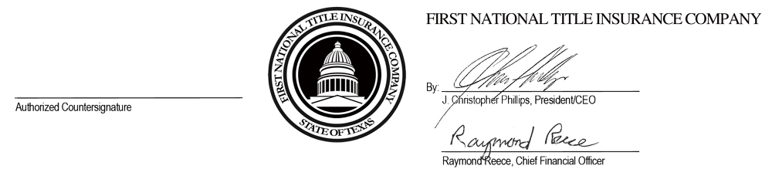
Date: ______________________

