 | CLTA Form 116.5.1-06  Manufactured Housing Unit-Conversion; Loan  ENDORSEMENT  Issued by  FIRST NATIONAL TITLE INSURANCE COMPANY

Attached to Policy No.___________________________

1. The term "Land" as defined in this policy includes the manufactured housing unit located on the land described in Schedule A at Date of Policy.

2. Unless excepted in Schedule B, the Company insures against loss or damage, sustained by the Insured if, at Date of Policy,

(a) A manufactured housing unit is not located on the land described in Schedule A.
(b) The manufactured housing unit located on the land is not real property under the law of the state where the Land described in Schedule A is located.
(c) The owner of the land is not the owner of the manufactured housing unit.
(d) Any lien is attached to the manufactured housing unit as personal property, including

(i) a federal, state, or other governmental tax lien,
(ii) UCC security interest,
(iii) a motor vehicular lien,
(iv) other personal property lien.

(e) The lien of the Insured Mortgage is not enforceable against the Land.
(f) The lien of the Insured Mortgage is not enforceable in a single foreclosure procedure.

This endorsement is issued as part of the policy. Except as it expressly states, it does not (i) modify any of the terms and provisions of the policy, (ii) modify any prior endorsements, (iii) extend the Date of Policy, or (iv) increase the Amount of Insurance. To the extent a provision of the policy or a previous endorsement is inconsistent with an express provision of this endorsement, this endorsement controls. Otherwise, this endorsement is subject to all of the terms and provisions of the policy and of any prior endorsements.

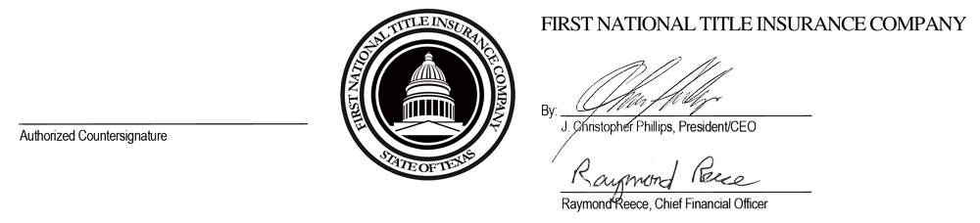
Date: ______________________

