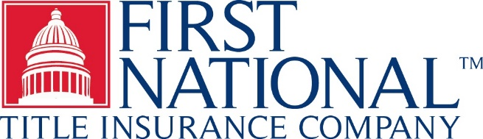 | TIRBOP - PA ENDORSEMENT 1031  (ALTA Endorsement 9.1-06)  (Covenants, Conditions and  Restrictions - Unimproved Land)  Issued By  FIRST NATIONAL TITLE INSURANCE COMPANY

Attached to and make a part of Policy No.: File No.:

1. The insurance provided by this endorsement is subject to the exclusions in Section 4 of this endorsement; and the Exclusions from Coverage, the Exceptions from Coverage contained in Schedule B, and the Conditions in the policy.

2. For the purposes of this endorsement only, "Covenant" means a covenant, condition, limitation or restriction in a document or instrument in effect at Date of Policy.

3. The Company insures against loss or damage sustained by the Insured by reason of:

a. A violation on the Land at Date of Policy of an enforceable Covenant, unless an exception in Schedule B of the policy identifies the violation; or

b. A notice of a violation, recorded in the Public Records at Date of Policy, of an enforceable Covenant relating to environmental protection describing any part of the Land and referring to that Covenant, but only to the extent of the violation of the Covenant referred to in that notice, unless an exception in Schedule B of the policy identifies the notice of the violation.

4. This endorsement does not insure against loss or damage (and the Company will not pay costs, attorneys' fees, or expenses) resulting from:

a. any Covenant contained in an instrument creating a lease;

b. any Covenant relating to obligations of any type to perform maintenance, repair, or remediation on the Land; or

c. except as provided in Section 3.b, any Covenant relating to environmental protection of any kind or nature, including hazardous or toxic matters, conditions, or substances.

This endorsement is issued as part of the policy. Except as It expressly states, it does not (i) modify any of the terms and provisions of the policy, (ii) modify any prior endorsements, (iii) extend the Date of Policy, or (iv) increase the Amount of Insurance. To the extent a provision of the policy or a previous endorsement is inconsistent with an express provision of this endorsement, this endorsement controls. Otherwise, this endorsement is subject to all of the terms and provisions of the policy and of any prior endorsements.

IN WITNESS WHEREOF, the Company has caused this endorsement to be issued and become valid when signed by an authorized officer or licensed agent of the Company.

