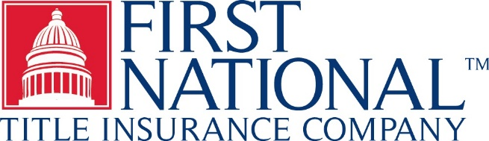 | TIRBOP - PA ENDORSEMENT 1550  (ALTA Endorsement 17.2-06)  (Utility Access)  Issued By  FIRST NATIONAL TITLE INSURANCE COMPANY

Attached to and make a part of Policy No.: File No.:

The Company insures against loss or damage sustained by the Insured by reason of the lack of a right of access to the following utilities or services: [CHECK ALL THAT APPLY]

□ Water service □ Natural gas service □ Telephone service

□ Electrical power service □ Sanitary sewer □ Storm water drainage

[□ ] [□ ] [□ ]

either over, under or upon rights-of-way or easements for the benefit of the Land because of:

(1) a gap or gore between the boundaries of the Land and the rights-of-way or easements;

(2) a gap between the boundaries of the rights-of-way or easements; or

(3) a termination by a grantor, or its successor, of the rights-of-way or easements.

This endorsement is issued as part of the policy. Except as it expressly states, it does not (i) modify any of the terms and provisions of the policy, (ii) modify any prior endorsements, (iii) extend the Date of Policy, or (iv) increase the Amount of Insurance. To the extent a provision of the policy or a previous endorsement is inconsistent with an express provision of this endorsement, this endorsement controls. Otherwise, this endorsement is subject to all of the terms and provisions of the policy and of any prior endorsements.

IN WITNESS WHEREOF, the Company has caused this endorsement to be issued and become valid when signed by an authorized officer or licensed agent of the Company.

