Attached to Loan Policy No.: __________
This endorsement is effective only if the Collateral includes at least two parcels of real property.
- For the purposes of this endorsement:
  - “Indebtedness” means all monetary obligations evidenced by the loan documents at Date of Policy as secured by the insured mortgage, but limited to the balance outstanding at the time the claim is made.
  - “Collateral” means all property, including the land, given as security for the Indebtedness.
  - “Material Impairment Amount” means the amount by which any matter covered by this policy for which a claim is made diminishes the value of the Collateral below the Indebtedness.
- Subject to the provisions of Section 8 of the Conditions, in the event of a claim resulting from a matter insured against by this policy, the Company agrees to pay that portion of the Material Impairment Amount that does not exceed the limits of liability imposed by Sections 2 and 7 of the Conditions without requiring:
  - maturity of the Indebtedness by acceleration or otherwise;
  - pursuit by the insured of its remedies against the Collateral;
  - pursuit by the insured of its remedies under any guaranty, bond or other insurance policy.
- Nothing in this endorsement shall impair the Company's right of subrogation. However, the Company agrees that its right of subrogation shall be subordinate to the rights and remedies of the insured. The Company's right of subrogation shall include the right to recover the amount paid to the insured pursuant to paragraph 2 from any debtor or guarantor of the Indebtedness, after payment or other satisfaction of the remainder of the Indebtedness and other obligations secured by the lien of the insured mortgage. The Company shall have the right to recoup from the insured claimant any amount received by it in excess of the Indebtedness up to the amount of the payment under paragraph 2.
This endorsement is issued as part of the policy. Except as it expressly states, it does not (i) modify any of the terms and provisions of the policy, (ii) modify any prior endorsements, (iii) extend the Date of Policy, or (iv) increase the Amount of Insurance. To the extent a provision of the policy or a previous endorsement is inconsistent with an express provision of this endorsement, this endorsement controls. Otherwise, this endorsement is subject to all of the terms and provisions of the policy and of any prior endorsements.
IN WITNESS HEREOF, the FIRST NATIONAL TITLE INSURANCE COMPANY has caused this Endorsement to be executed by its President under the seal of the Company, but this Endorsement is to be valid only when it bears an authorized counter signature.

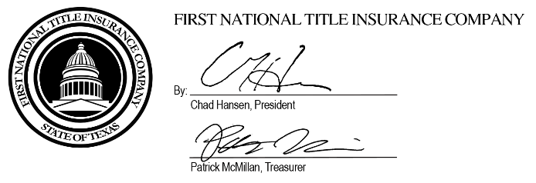

Authorized Countersignature

