Attached to Policy No.: __________
- The insurance provided by this endorsement is subject to the exclusions in Section 5 of this endorsement; and the Exclusions from Coverage, the Exceptions from Coverage contained in Schedule B, and the Conditions in the policy.
- For the purposes of this endorsement only:
  - “Covenant” means a covenant, condition, limitation or restriction in a document or instrument in effect at Date of Policy.
  - “Improvement” means an improvement, including any landscaping, lawn, shrubbery, or trees, affixed to either the Land or adjoining land that by law constitutes real property.
  - “Private Right” means (i) an option to purchase; (ii) a right of first refusal; (iii) a right of prior approval of a future purchaser or occupant; or (iv) a private charge or assessment.
- The Company insures against loss or damage sustained by the Insured by reason of:
  - A violation of a Covenant that:
    - divests, subordinates, or extinguishes the lien of the Insured Mortgage,
    - results in the invalidity, unenforceability or lack of priority of the lien of the Insured Mortgage, or
    - causes a loss of the Insured’s Title acquired in satisfaction or partial satisfaction of the Indebtedness;
  - A violation on the Land at Date of Policy of an enforceable Covenant, unless an exception in Schedule B of the policy identifies the violation;
  - Enforced removal of an Improvement located on the Land at Date of Policy as a result of a violation, at Date of Policy, of a building setback line shown on a plat of subdivision recorded or filed in the Public Records, unless an exception in Schedule B of the policy identifies the violation;
  - A notice of a violation, recorded in the Public Records at Date of Policy, of an enforceable Covenant relating to environmental protection describing any part of the Land and referring to that Covenant, but only to the extent of the violation of the Covenant referred to in that notice, unless an exception in Schedule B of the policy identifies the notice of the violation; or
  - Enforcement of a Private Right in a Covenant affecting the Title at Date of Policy that:
    - results in the invalidity, unenforceability or lack of priority of the lien of the Insured Mortgage, or
    - causes a loss of the Insured’s Title acquired in satisfaction or partial satisfaction of the Indebtedness.
- The Company insures against loss or damage sustained by reason of:
  - An encroachment of:
    - an Improvement located on the Land, at Date of Policy, onto adjoining land or onto that portion of the Land subject to an easement; or
    - an Improvement located on adjoining land onto the Land at Date of Policy
unless an exception in Schedule B of the policy identifies the encroachment otherwise insured against in Sections 4.a.i. or 4.a.ii.; or
  - A final court order or judgment requiring the removal from any land adjoining the Land of an encroachment identified in Schedule B; or
  - Damage to an Improvement located on the Land, at Date of Policy that is located on or encroaches onto that portion of the Land subject to an easement excepted in Schedule B, which damage results from the exercise of the right to maintain the easement for the purpose for which it was granted or reserved; or
  - Damage to Improvements located on the Land on or after Date of Policy, resulting from the future exercise of any right existing at the Date of Policy to use the surface of the Land for the extraction or development of coal, lignite, oil, gas, or other minerals or any other subsurface substances excepted or excluded on Schedule A, Item 2, or excepted in Schedule B.
- This endorsement does not insure against loss or damage (and the Company will not pay costs, attorneys' fees, or expenses) resulting from:
  - any Covenant contained in an instrument creating a lease;
  - any Covenant relating to obligations of any type to perform maintenance, repair, or remediation on the Land;
  - except as provided in Paragraph 3.d, any Covenant relating to environmental protection of any kind or nature, including hazardous or toxic matters, conditions, or substances;
  - contamination, explosion, fire, fracturing, vibration, earthquake, flood, or subsidence; or
  - negligence by a person or an Entity exercising a right to extract or develop minerals or other subsurface substances.
This endorsement is issued as part of the policy. Except as it expressly states, it does not (i) modify any of the terms and provisions of the policy, (ii) modify any prior endorsements, (iii) extend the Date of Policy, or (iv) increase the Amount of Insurance. To the extent a provision of the policy or a previous endorsement is inconsistent with an express provision of this endorsement, this endorsement controls. Otherwise, this endorsement is subject to all of the terms and provisions of the policy and of any prior endorsements.

IN WITNESS HEREOF, the FIRST NATIONAL TITLE INSURANCE COMPANY has caused this Endorsement to be executed by its President under the seal of the Company, but this Endorsement is to be valid only when it bears an authorized counter signature.

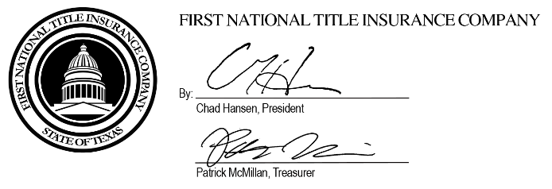

Authorized Countersignature

