Attached to and made a part of First National Title Insurance Company Policy Number __________, this _____ day of __________, _____.
- Said policy is hereby amended so that its coverage shall relate to date of this Endorsement instead of the date of the policy, subject to:
  - The exceptions shown in Schedule B of said policy and in any prior Endorsement to said policy,
  - Matters which would be shown by a correct survey and inspection of the premises subsequent to the date of said policy,
  - Any and all liens arising by reason of unpaid bills or claims for work performed or material furnished in connection with the improvements being placed upon the subject land: The Company does, however, insure against loss, if any, sustained by the insured under the terms of the policy, if any such liens have been filed with the County Clerk of the County in which such property is located prior to the date of this Endorsement, except those liens set forth in Schedule B of said policy or in any prior Endorsement to said policy, and except:
[Specify or delete immediately preceding words "and except".]
  - The following additions to Schedule B of said policy:
[Specify or delete this paragraph and include as exceptions only those additional matters which the Company has determined are superior to the lien described in Schedule A, Item 4, of said policy.]
  - The following matters which affect the title to the estate or interest in the land described or referred to in Schedule A of said policy, but Company insures the insured against loss, if any, sustained by the insured under the terms of the policy if such matters are not subordinate to the lien described in Schedule A, Item 4, of said policy:
[Specify or delete this paragraph.]
- The coverage under said policy as of the date hereof is $____________________.

Nothing herein contained shall be construed as extending or changing the effective date of the aforesaid policy or interim construction binder, unless otherwise expressly stated.
IN WITNESS HEREOF, the FIRST NATIONAL TITLE INSURANCE COMPANY has caused this Endorsement to be executed by its President under the seal of the Company, but this Endorsement is to be valid only when it bears an authorized counter signature.

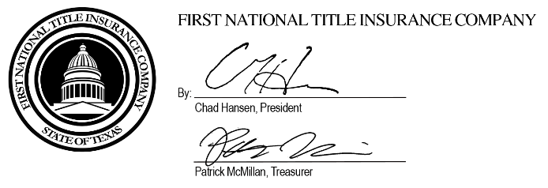

Authorized Countersignature

