This Endorsement is made a part of Owner Policy Number __________, dated __________.
As of the date of this endorsement, the "Amount" on Schedule A is deleted and the following amount is substituted:
$ __________.
Under this endorsement, we do not cover title risks or insure against matters:
a. created, suffered, assumed, or agreed to by you (the insured), or
b. known to you (the insured) but not to us (the company) at the date of this endorsement unless they appear in the Public Records on the Policy Date.
This endorsement does not change the Policy Date. The terms of the Policy apply to this endorsement.
Endorsement Premium: $__________
Endorsement Date: __________, 20_____


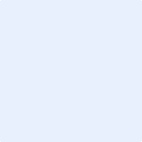
Authorized Countersignature

