Attached to Policy No.: __________
The Company insures against loss or damage sustained by the Insured by reason of an environmental protection lien that, at Date of Policy, is recorded in the Public Records or filed in the records of the clerk of the United States district court for the district in which the Land is located, unless the environmental protection lien is set forth as an exception in Schedule B.
This endorsement is issued as part of the policy. Except as it expressly states, it does not (i) modify any of the terms and provisions of the policy, (ii) modify any prior endorsements, (iii) extend the Date of Policy, or (iv) increase the Amount of Insurance. To the extent a provision of the policy or a previous endorsement is inconsistent with an express provision of this endorsement, this endorsement controls. Otherwise, this endorsement is subject to all of the terms and provisions of the policy and of any prior endorsements.
IN WITNESS HEREOF, the FIRST NATIONAL TITLE INSURANCE COMPANY has caused this Endorsement to be executed by its President under the seal of the Company, but this Endorsement is to be valid only when it bears an authorized counter signature.

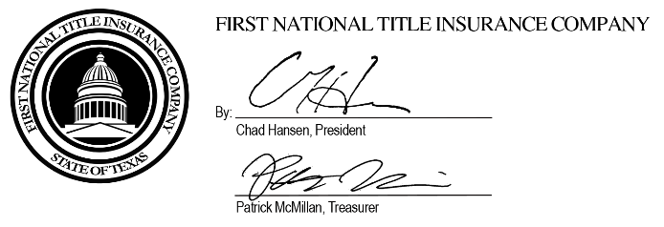

Authorized Countersignature

